1. 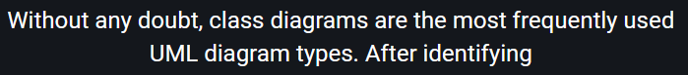
2. 
3. 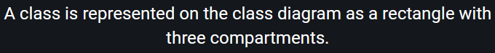 
4. 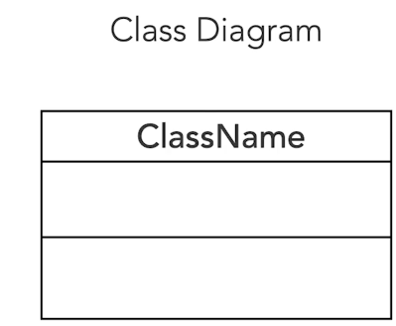
5.     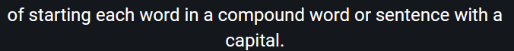
6. 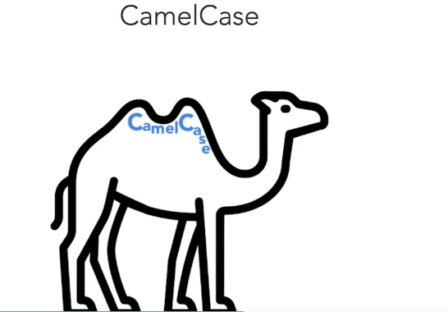
7. 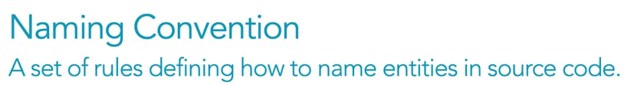
8. We can easily read the source code written by other developers, even if they are from another company, country or continent.
9. Attribute names must follow the lowercase camel case style.
10. **Operation Compartment**:
    1. This is where we list the class’s methods.
    2. Method names should be verbs in Lower Camel Case.
    3. Parameters appear within the parenthesis as **name-dataType.**
    4. To show a method returns something, just add colon after the closing parenthesis followed by the return type.
11. 